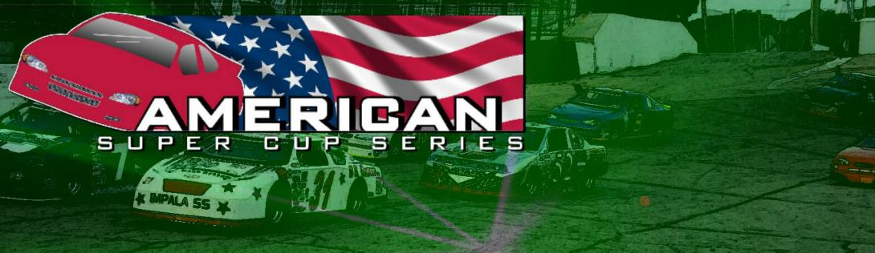
2014 Event Schedule
Fri.-Sun. Feb 21st -23rd World Of Wheels, Milwaukee, WI
Sat. Apr 19th Kettle Moraine Car Show, Slinger, WI
Race 1: Sun May 4th Slinger Speedway
Race 2: Sat May 17th Rockford Speedway
Race 3: Mon May 26th Golden Sands Speedway
Race 4: Sat Jun 7th Rockford Speedway
Race 5: Sat Jun 21st Dells Raceway Park
Race 6: Sun Jul 6th Slinger Speedway
Race 7: Sat Jul 19th Rockford Speedway
Race 8: Sat Aug 9th Rockford Speedway
Sat.-Sun August 16th-17th IndyFest, Milwaukee, WI
Race 9: Sat Aug 23rd Dells Raceway Park
Race 10: Sat Aug 30th Indy Speedrome
Race 11: Sun Aug 31st Indy Speedrome
Race 12: Sun Sept 6th Slinger Speedway
*Subject to change

