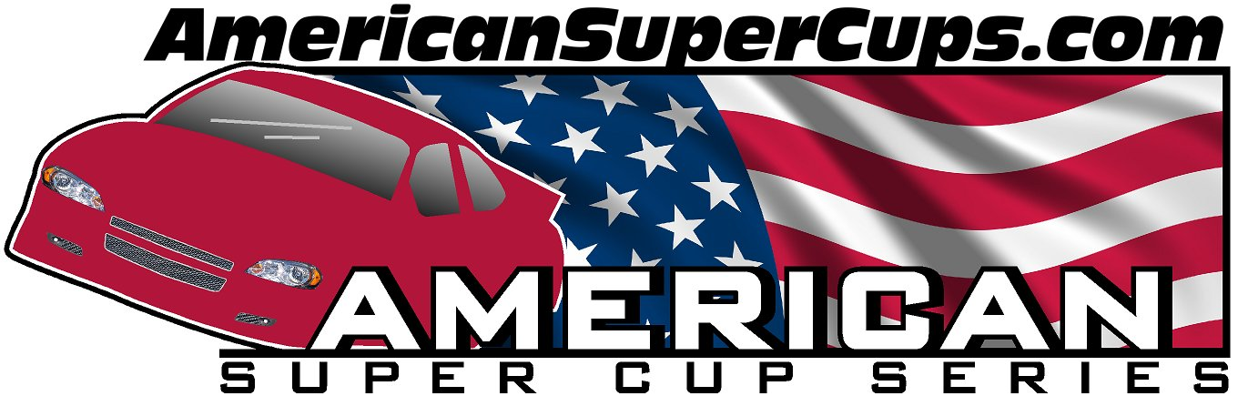

2013
Super Cup Racing Schedule

- Sun May 5th Slinger Super Speedway
- Sat May 18th Rockford Speedway
- Mon May 27th Golden Sands Speedway
- Sat Jun 8th Indianapolis Speedrome
- Sat Jun 22nd Rockford Speedway
- Sat Jul 6th Lacrosse Speedway
- Sun Jul 21st Slinger Super Speedway
- Sat Aug 3rd Dells Raceway Park
- Sat Aug 17th Rockford Speedway
- Sat Aug 31st Indianapolis Speedrome
- Sun Sept 1st Indianapolis Speedrome
- Sun Sept 8th Slinger Super Speedway

www.AmericanSuperCups.com

Revised: 02-26-13 (Subject to change without notice)

