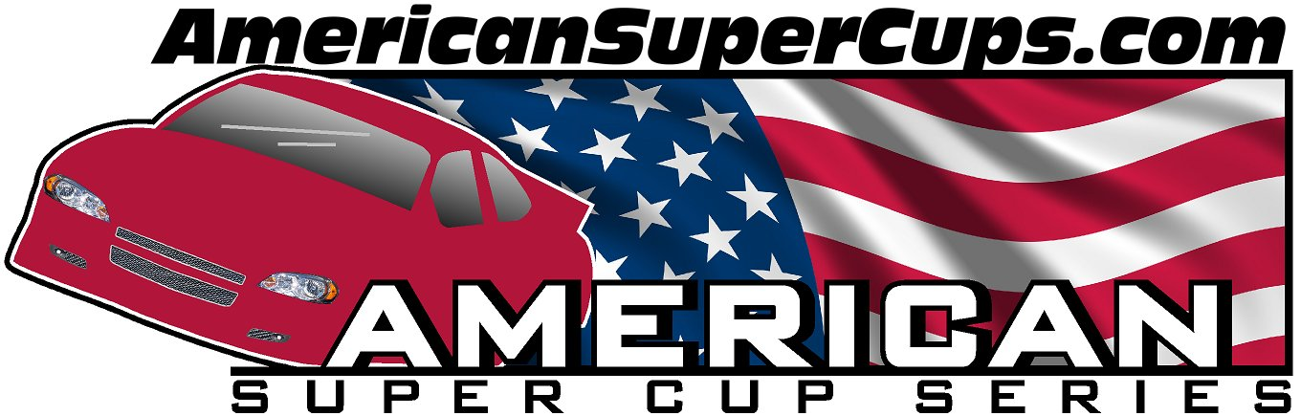

2012
Super Cup Racing Schedule

(Practice Dates)
Sat. April 7th Rockford Speedway, Rockford, IL
Thu. April 19th Rockford Speedway, Rockford, IL
Sat. April 28th Slinger Super Speedway, Slinger, WI
(Regular Season Begins)
Sat. May 5th Indnpls Speedrome, Indianapolis, IN
Sun. May 20th Slinger Super Speedway, Slinger, WI
Mon. May 28th Golden Sands, Wisconsin Rapids, WI
Sat. June 9th Rockford Speedway, Rockford, IL
Sun. June 17th Slinger Super Speedway, Slinger, WI
Sat. July 7th Lacrosse Speedway, LaCrosse, WI
Sat. July 14th Rockford Speedway, Rockford, IL
Sat. July 28th Indpls Speedrome, Indianapolis, IN
Sat. Aug 11th Lacrosse Speedway, LaCrosse, WI
Sat. Aug 18th Dells Raceway, Wisconsin Dells, WI
Sat. Sept 1-3 Rock Island GP, Rock Island, IL **
Sun. Sept 9th Slinger Super Speedway, Slinger, WI

** Exhibition/Non-Points Races

www.AmericanSuperCups.com

Revised: 03-23-12 (Subject to change without notice)

